Oruta: Privacy-Preserving Public Auditing
for Shared Data in the Cloud
Abstract:
With cloud storage services, it is commonplace for data to be not only stored in the cloud, but also shared across multiple users. However, public auditing for such shared data— while preserving identity privacy — remains to be an open challenge. In this paper, we propose the first privacy-preserving mechanism that allows public auditing on shared data stored in the cloud. In particular, we exploit ring signatures to compute the verification information needed to audit the integrity of shared data. With our mechanism, the identity of the signer on each block in shared data is kept private from a third party auditor (TPA), who is still able to verify the integrity of shared data without retrieving the entire file. Our experimental results demonstrate the effectiveness and efficiency of our proposed mechanism when auditing shared data.

Existing System:
The first provable data possession (PDP) mechanism [2] to perform public auditing is designed to check the correctness of data stored in an un trusted server, without retrieving the entire data. Moving a step forward, Wang et al. [3] (referred to as WWRL in this paper) is designed to construct a public auditing mechanism for cloud data, so that during public auditing, the content of private data belonging to a personal user is not disclosed to the third party auditor.

Disadvantage:
Data is not in an encrypted format.
Proposed System:
In this paper, we only consider how to audit the integrity of shared data in the cloud with static groups. It means the group is pre-defined before shared data is created in the cloud and the membership of users in the group is not changed during data sharing. The original user is responsible for deciding who is able to share her data before outsourcing data to the cloud. Another interesting problem is how to audit the integrity of shared data in the cloud with dynamic groups — a new user can be added into the group and an existing group member can be revoked during data sharing — while still preserving identity privacy.

Advantage:
Here we proposed the secured system and data owner can decide whether the user can access the system or not.

PROBLEM STATEMENT:
In our model, privacy is accomplished by allowing the parties to upload their data in multi clouds and data is split into multiple parts so it gives more protection
Scope:
We are going to raise the privacy level of the data owner and the confidentiality of the data in a better way through the multiple cloud environment.
Architecture:
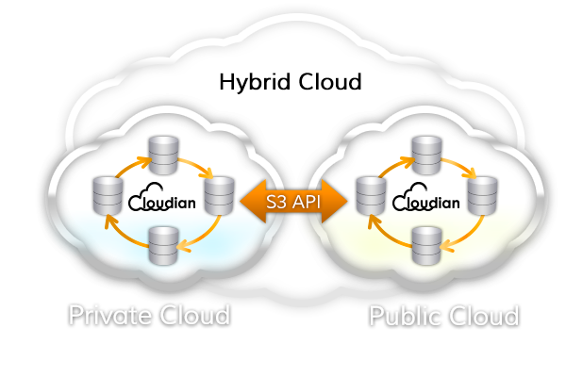

Modules :
- Owner
- Third Party Auditor
- User
- Data Sharing

Modules Description

OwnerRegistration:
In this module an owner has to upload its files in a cloud server, he/she should register first. Then only he/she can be able to do it. For that he needs to fill the details in the registration form. These details are maintained in a database.

Owner Login:
In this module,any of the above mentioned person have to login,they should login by giving their emailid and password .

User Registration:
In this module if a user wants to access the data which is stored in a cloud,he/she should register their details first. These details are maintained in a Database.

User Login:
If the user is an authorized user,he/she can download the file by using file id which has been stored by data owner when it was uploading.

ThirdPartyAuditor Registration:
In this module , if a third party auditor TPA(maintainer of clouds) wants to do some cloud offer , they should register first. Here we are doing like, this system allows only three cloud service providers.

ThirdPartyAuditor Login:
After third party auditor gets logged in, He/ She can see how many data owners have uploaded their files into the cloud. Here we are providing three tpa for maintaining three different clouds.

Data Sharing:
we only consider how to audit the integrity of shared data in the cloud with static groups. It means the group is pre-defined before shared data is created in the cloud and the membership of users in the group is not changed during data sharing. The original user is responsible for deciding who is able to share her data before outsourcing data to the cloud. Another interesting problem is how to audit the integrity of shared data in the cloud with dynamic groups — a new user can be added into the group and an existing group member can be revoked during data sharing — while still preserving identity privacy.

Proposed System:
To enable the TPA efficiently and securely verify shared data for a group of users, Oruta should be designed to achieve following properties: (1) Public Auditing: The third party auditor is able to verify the integrity of shared data for a group of users without retrieving the entire data. (2) Correctness:The third party auditor is able to correctly detect whether there is any corrupted block in shared data. (3) Unforgeability: Only a user in the group can generate valid verification information on shared data. (4) Identity Privacy: During auditing, the TPA cannot distinguish the identity of the signer on each block in shared data.

System Configuration:-

H/W System Configuration:-

Processor - Pentium –III

Speed - 1.1 GHz
RAM - 256 MB (min)
Hard Disk - 20 GB
Floppy Drive - 1.44 MB
Key Board - Standard Windows Keyboard
Mouse - Two or Three Button Mouse
Monitor - SVGA

S/W System Configuration:-

- Operating System :Windows95/98/2000/XP
- Application Server : Tomcat5.0/6.X
- Front End : HTML, Java, Jsp
- Scripts : JavaScript.
- Server side Script : Java Server Pages.
- Database : My sql
- Database Connectivity : JDBC.

Literature survey:
Literature survey is the most important step in software development process. Before developing the tool it is necessary to determine the time factor, economy n company strength. Once these things r satisfied, ten next steps are to determine which operating system and language can be used for developing the tool. Once the programmers start building the tool the programmers need lot of external support. This support can be obtained from senior programmers, from book or from websites. Before building the system the above consideration are taken into account for developing the proposed system.

Conclusion:
In this paper, we propose Oruta, the first privacy-preserving public auditing mechanism for shared data in the cloud. With Oruta, the TPA is able to efficiently audit the integrity of shared data, yet cannot distinguish who is the signer on each block, which can preserve identity privacy for users. An interesting problem in our future work is how to efficiently audit the integrity of shared data with dynamic groups while still preserving the identity of the signer on each block from the third party auditor.

